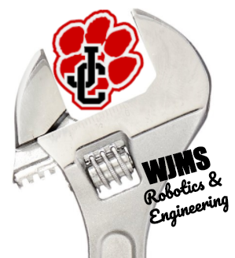 | MazeBot Challenge Part 1 Rubric
You will have 4 days to program your Basic Bot to move through 3 progressively difficult mazes in order to earn the highest amount of points. During this challenge you will learn to code and maintain lengthy programs as well as use and maintain your robot throughout the challenge. To determine a winner for this challenge the point values for each maze are listed below…

Complete Maze 1 = 100 points
Complete Maze 2 = 200 points
Complete Maze 3 = 300 points
Drive outside of the course = -10 points for each instance of both wheels crossing the boundary line.
Speed bonus: 1st to complete a maze = 50 points (then decreases by 10 points by each student completion i.e. 1st = 50 points, 2nd = 40 points, 3rd = 30 points)

MazeBot Challenge Part 1 Scoring Rubric
Student completes Maze 1 | _____ / 30 points
Student completes Maze 2 | _____/ 20 points
Student completes Maze 3 | _____/ 10 points
Student uses FUNCTIONS in their MazeBot programs. | _____/10 points
Student thoroughly completes the MazeBot Challenge Part 1 Reflection page. | _____/ 30 points

Total _____/ 100 points

