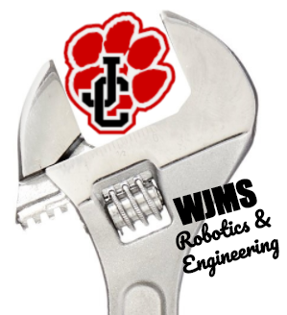 | MazeBot Challenge Part 2 Rubric
You will have 2 days to build your “Comp Bot 2.0”, and 4 days to program it to move through 2 progressively difficult mazes in order to earn the highest amount of points. During this challenge you will learn to use a remote control with your robot while also programming it to move autonomously through the “No Radio Zones”. To determine a winner for this challenge the point values for each maze are listed below…

Successfully Deliver Supplies at the end of Maze 1 = 100 points
Successfully Deliver Supplies at the end of Maze 2 = 200 points
Each “No Radio Zone” Completed = 300 points
Each Zombie Knocked Over = 10 points
Drive outside of the course = -10 points for each instance of both wheels crossing the boundary line.
Speed bonus: 1st to complete a maze = 50 points (then decreases by 10 points by each student completion i.e. 1st = 50 points, 2nd = 40 points, 3rd = 30 points)

MazeBot Challenge Part 1 Scoring Rubric
Student builds a working Comp Bot 2.0 | ____/20 points
Student completes Maze 1 | _____ / 30 points
Student completes Maze 2 | _____/ 20 points
Student scored highly by teammate on MazeBot 2 Peer Review | _____/ 10 points
Student thoroughly completes the MazeBot Challenge Part 1 Reflection page. | _____/ 20 points

Total _____/ 100 points

